Table of Contents

Background/Introduction 1

Software to Install to Connect to the Database Used AOS on Nimbus 1

Install 32-bit ODBC driver software 1

Install software to graphically view and manage a postgres database 1

Configure odbc connection 2

# Background/Introduction

UFT One database activities (output or checkpoint) are very easy, but require a 32-bit ODBC connection in order to work. This document discusses how to create the connection.

Note that on NimbusClient – the ODBC connection is already present, as of version TBD. These instructions are being provided in case you have a need prior to the connection being present on NimbusClient, or if you have UFT installed on a non-nimbus environment, such as your desktop.

Because of basic security/firewalls, the database activities will only work on AOS running on NimbusServer. The ports and even the FQDM of the database used in the public AOS are not available.

# Software to Install to Connect to the Database Used AOS on Nimbus

NimbusServer AOS installation uses postgres (v10 as of now) as its database.

There are two software installations to be done for connectivity from NimbusClient

1. 32-bit ODBC connection driver (mandatory)
2. Postgres database viewing software (optional, but highly recommended)

Note that there are many possible tools/media files solutions for Postgres and ODBC drivers. The following are open-sourced licensed.

## Install 32-bit ODBC driver software

The software can be downloaded from <https://www.postgresql.org/ftp/odbc/versions/msi/>

Be sure to select a compatible version (10) and architecture (32-bit->x86, as opposed to 64-bit->x64). Simply double click on psqlodbc_10_03_0000-x86.zip to extract, then run the .exe. Take all defaults.

## Install software to graphically view and manage a postgres database

The software can be downloaded from

<https://www.enterprisedb.com/downloads/postgres-postgresql-downloads>

Be sure to select a compatible version (10) but 32 or 64 bit architecture does not matter. Take all defaults.

This installer includes the PostgreSQL server, pgAdmin; a graphical tool for managing and developing your databases. To connect to the AOS database, you use the same credentials in the next section.

# Configure odbc connection

Start the 32-bit ODBC Administrator (run:  %systemdrive%\Windows\SysWoW64\odbcad32.exe).

In the ODBC Data Source Administrator (32-bit) window, Select the System DSN tab. Scroll to find “PostgresSQL ANSI (They are alphabetical) and select it.

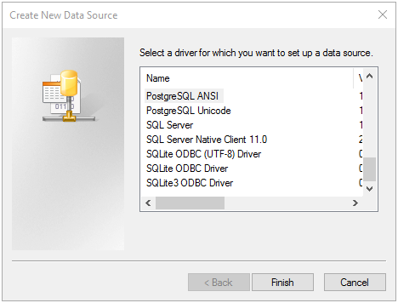

The following window appears.

* Note that the Data Source Name is hard coded in the script, so be sure to use exactly the string “AOS_Database” as shown below
* The Database Name was determined from pgAdmin 4
* For Password, use: Ptr9=k_.A*xx=PGn

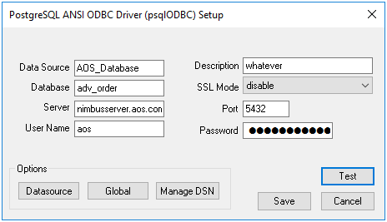

Note – within UFT, if you create a new database checkpoint or output value, within Microsoft Query, you may see:

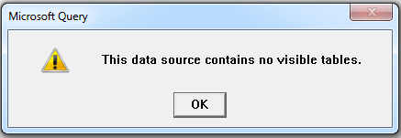

To fix this, hit OK, then select Options…

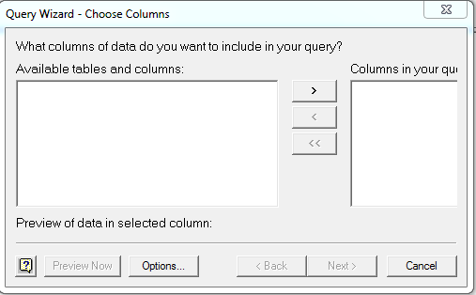

Enable System Tables by clicking the box

